MIS 6326.501 – Data Management - Assignment 6A
Swetha Krishnakumar (sxk151530)

Assignment 6A Triggers and DB Performance Tuning

Total points: 25

This assignment should be completed individually. For each problem, submit your SQL statement and a screen shot of the SQL results in a single Word document or pdf file. Submit the file via eLearning.

I recommend creating a new user and workspace, log in as that user and load the database script ourvideo_A2.sql (provided in this week's assignment folder).
Before you attempt to write any SQL queries, familiarize yourself with the database structure and data. I have provided a relational diagram and sample data for this database.
Write queries to address each of the problems below. Submit both the SQL statements and the screen prints of the outputs from Oracle.
OurVideo is a small movie rental company with a single store. OurVideo needs a database system to track the rental of movies to its members. OurVideo can own several copies (VIDEO) of each movie (MOVIE). For example, the store may have 10 copies of the movie “Twist in the Wind”. “Twist in the Wind” would be one MOVIE and each copy would be a VIDEO. A rental transaction (RENTAL) involves one or more videos being rented to a member (MEMBERSHIP). A video can be rented many times over its lifetime, therefore, there is a M:N relationship between RENTAL and VIDEO. DETAILRENTAL is the bridge table to resolve this relationship. The complete ERD is provided in the Figure below.
OurVideo ERD
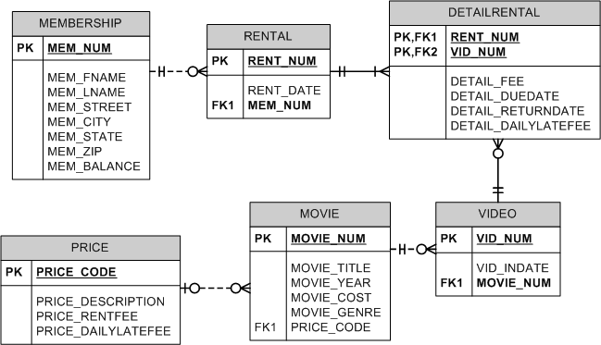

- Alter the VIDEO table to include an attribute named VID_STATUS to store character data up to 4 characters long. The attribute should not accept null values. The attribute should have a constraint to enforce the domain (“IN”, “OUT”, and “LOST”), and have a default value of “IN”. (3 pts)

Solution:
Alter Table VIDEO ADD (VID_STATUS VARCHAR(4) DEFAULT 'IN' NOT NULL CONSTRAINT VID_CK1 CHECK(VID_STATUS IN('IN','OUT','LOST')))

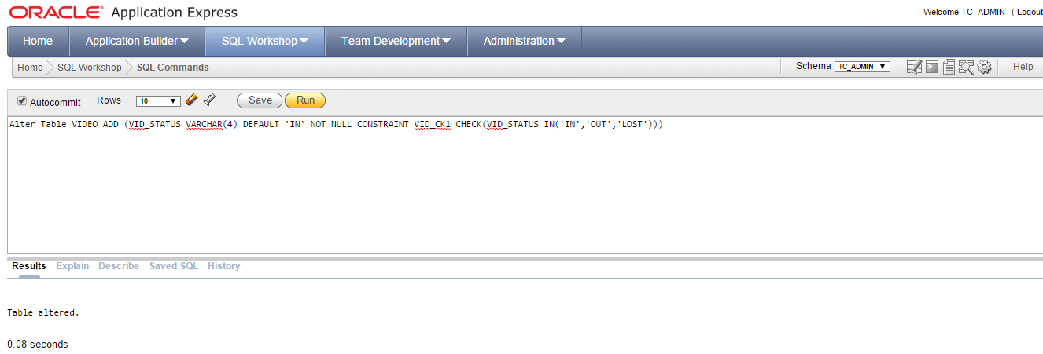

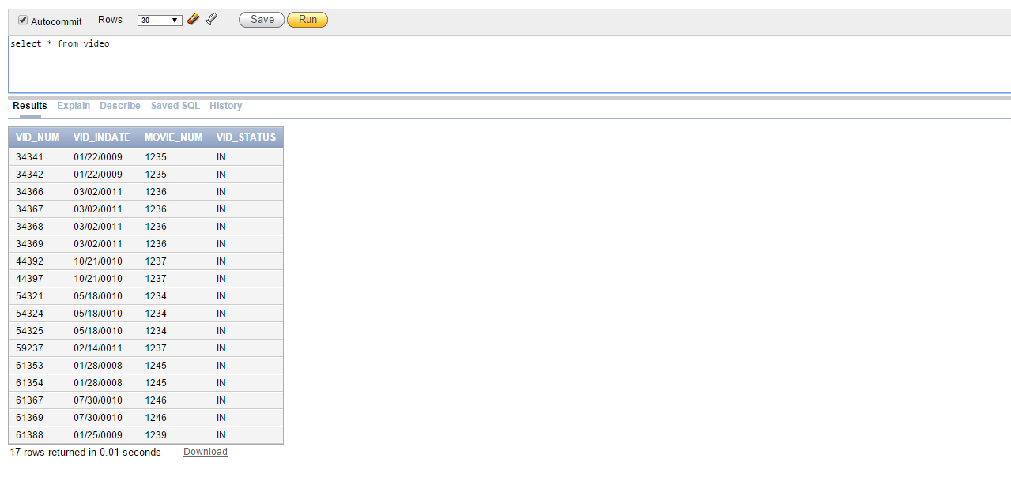

- Create a trigger named trg_videorental_up that will update the correct value VID_STATUS in the VIDEO table whenever a video is checked out (OUT) or returned (IN). The trigger should execute as an AFTER trigger when the DETAIL_DUEDATE or DETAIL_RETURNDATE attributes are updated in the DETAILRENTAL table. The trigger should satisfy the following conditions:
  - If he DETAIL_RETURNDATE in the detail rental table is set to NULL, the VID_STATUS should be set to “OUT”.
  - If the DETAIL_RETURNDATE in the detail rental table is set to > than the current date, the VID_STATUS should be set to “OUT”.
  - If the DETAIL_RETURNDATE in the detail rental table is set to < or = to the current date, the VID_STATUS should be set to “IN”.
  - If the DETAIL_RETURNDATE in the detail rental table is set to “01/01/01”, the VID_STATUS should be set to “LOST”.

Solution:
CREATE OR REPLACE TRIGGER TRG_VIDEORENTAL_UP
AFTER UPDATE OF DETAIL_DUEDATE,DETAIL_RETURNDATE ON DETAILRENTAL
FOR EACH ROW
BEGIN
IF (:NEW.DETAIL_RETURNDATE IS NULL) THEN
UPDATE VIDEO SET VID_STATUS = 'OUT' WHERE VIDEO.VID_NUM = :OLD.VID_NUM;
ELSIF (TO_DATE(:NEW.DETAIL_RETURNDATE,'DD-MON-YY') > TO_DATE(TO_CHAR(SYSDATE,'DD-MON-YY'),'DD-MON-YY')) THEN
UPDATE VIDEO SET VID_STATUS = 'OUT' WHERE VIDEO.VID_NUM = :OLD.VID_NUM;
ELSIF (TO_DATE(:NEW.DETAIL_RETURNDATE,'DD-MON-YY') <= TO_DATE(TO_CHAR(SYSDATE,'DD-MON-YY'),'DD-MON-YY') AND :NEW.DETAIL_RETURNDATE != '01-JAN-01') THEN
UPDATE VIDEO SET VID_STATUS = 'IN' WHERE VIDEO.VID_NUM = :OLD.VID_NUM;
ELSIF (:NEW.DETAIL_RETURNDATE = '01-JAN-01') THEN
UPDATE VIDEO SET VID_STATUS = 'LOST' WHERE VIDEO.VID_NUM = :OLD.VID_NUM;
END IF;
END;

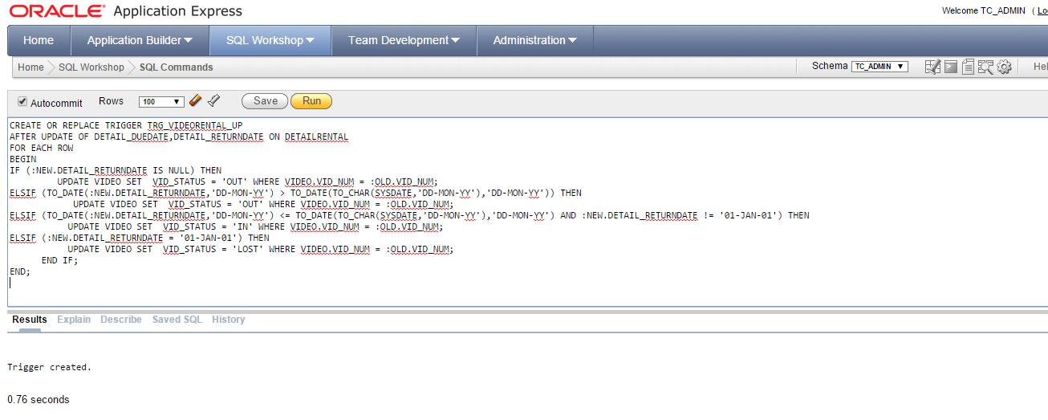

--After you have created the trigger, test the trigger. Update a record for each scenario into the detail rental table. Show the update statements. To show that the trigger has run, show the output from the following query:

Solution:
- UPDATE DETAILRENTAL SET DETAIL_RETURNDATE = NULL where VID_NUM = 61369

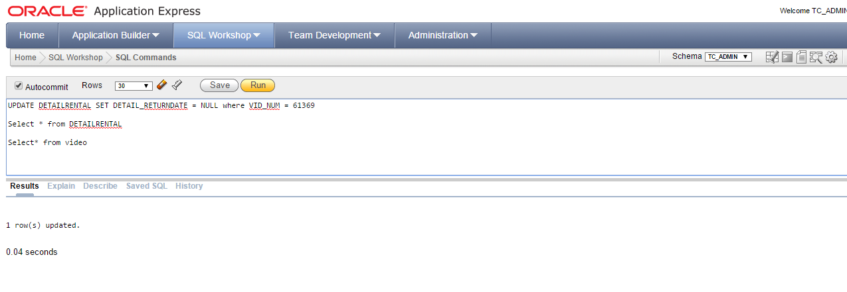
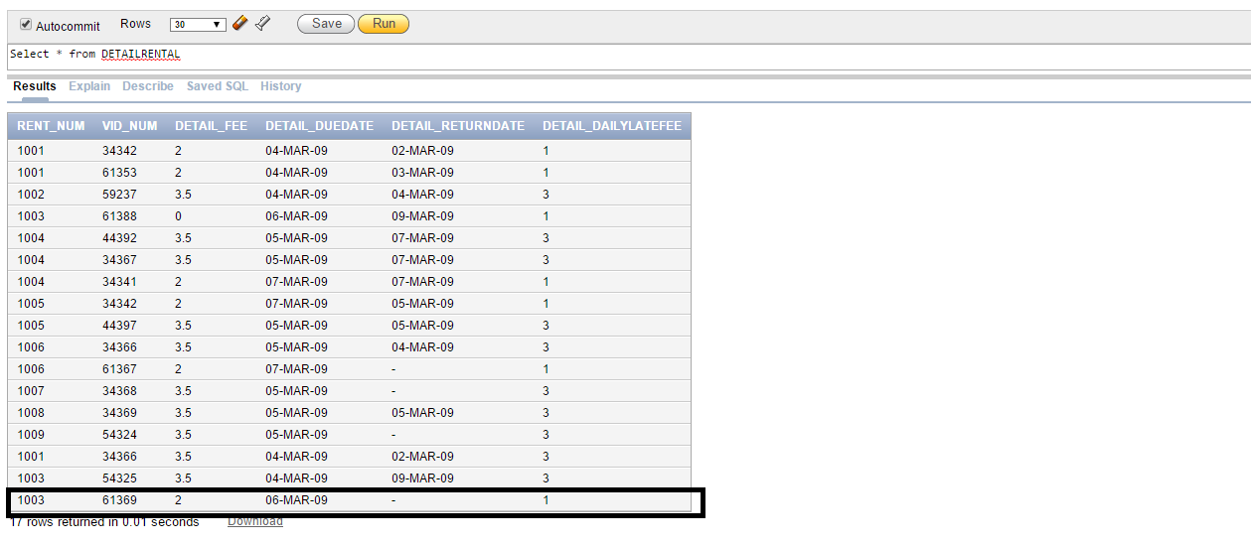
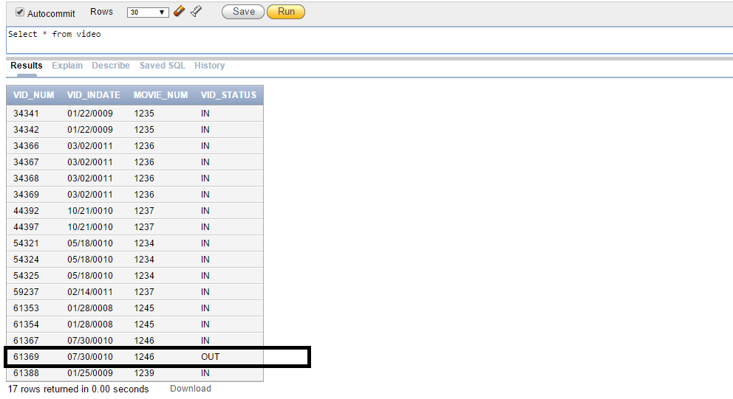

- UPDATE DETAILRENTAL SET DETAIL_RETURNDATE = '30-NOV-15' where VID_NUM = 61369
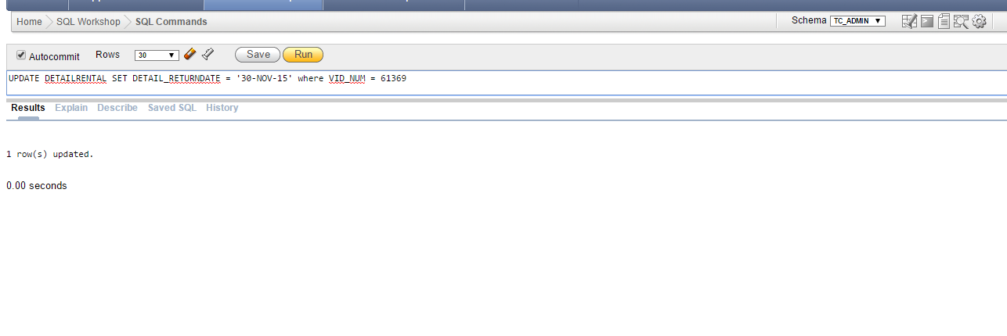
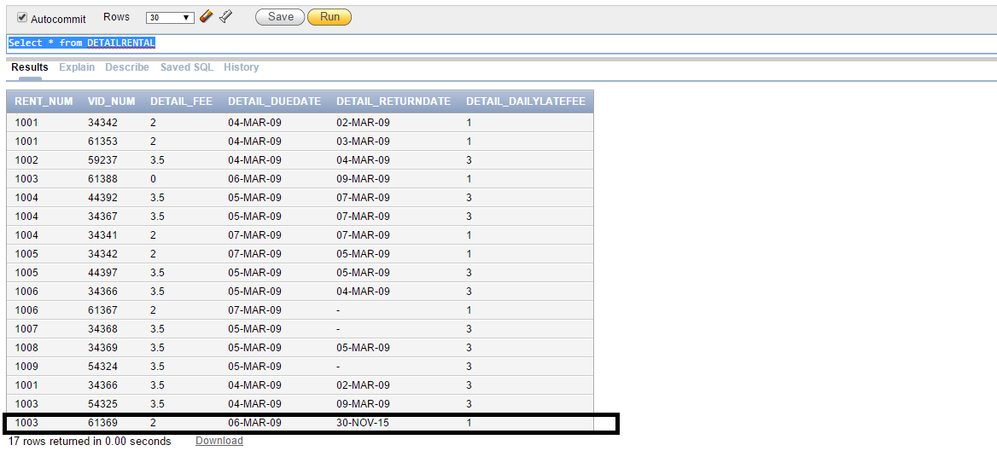
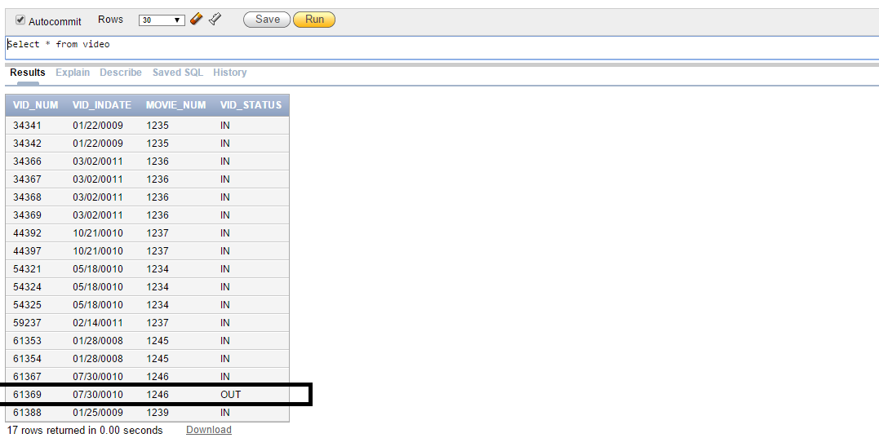

- UPDATE DETAILRENTAL SET DETAIL_RETURNDATE = '28-NOV-15' where VID_NUM = 61369
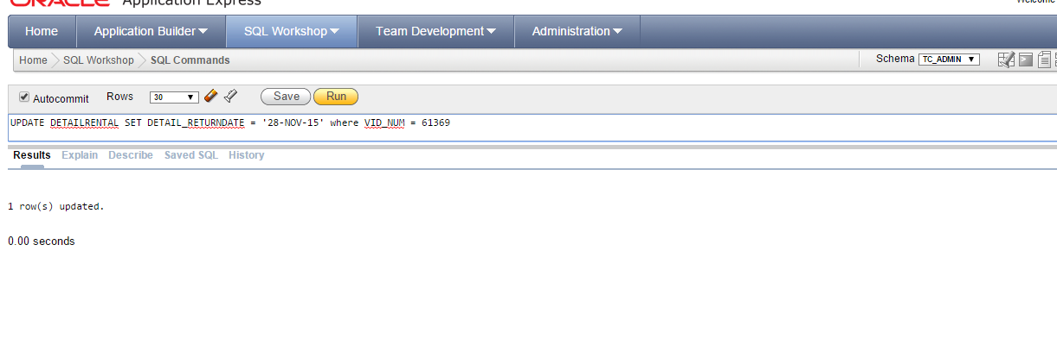
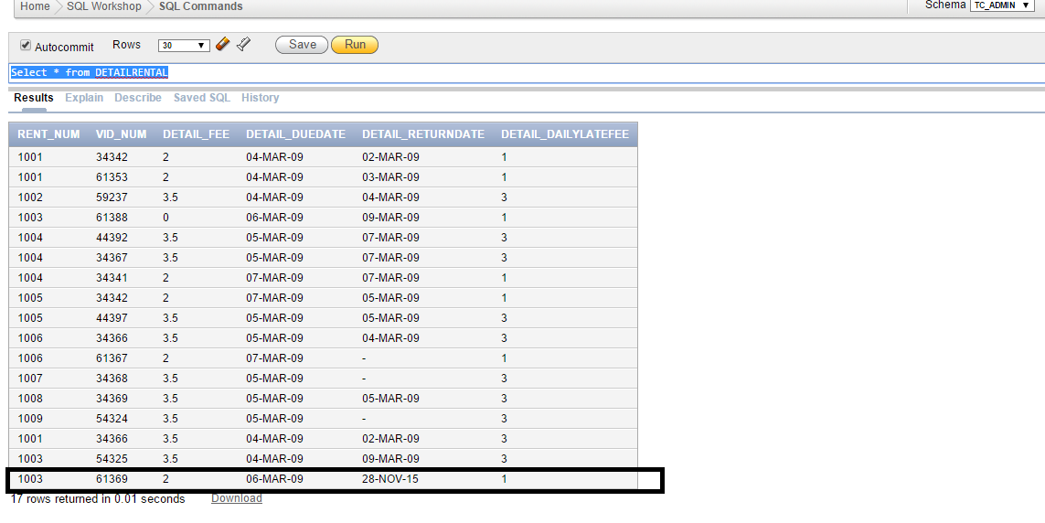
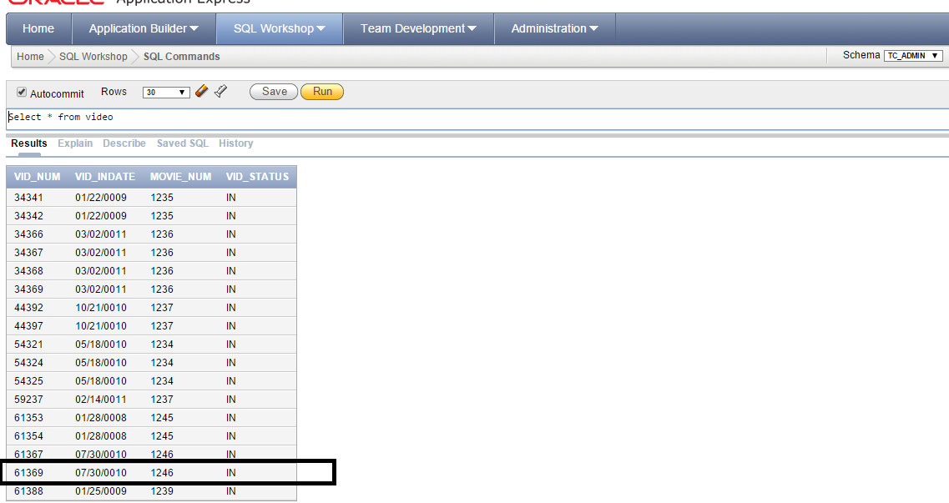

- UPDATE DETAILRENTAL SET DETAIL_RETURNDATE = '01-JAN-01' where VID_NUM = 61369

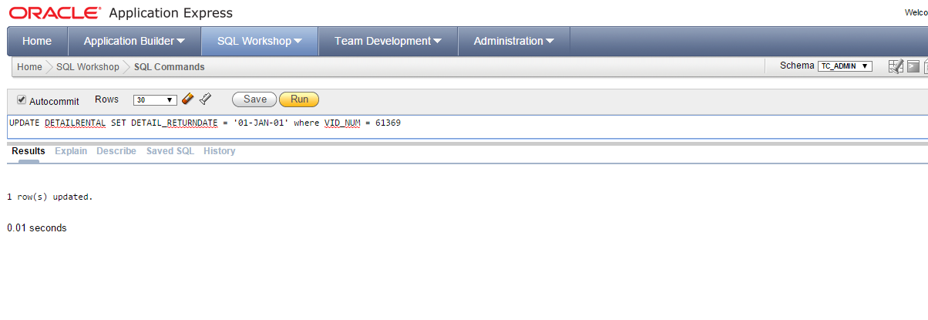
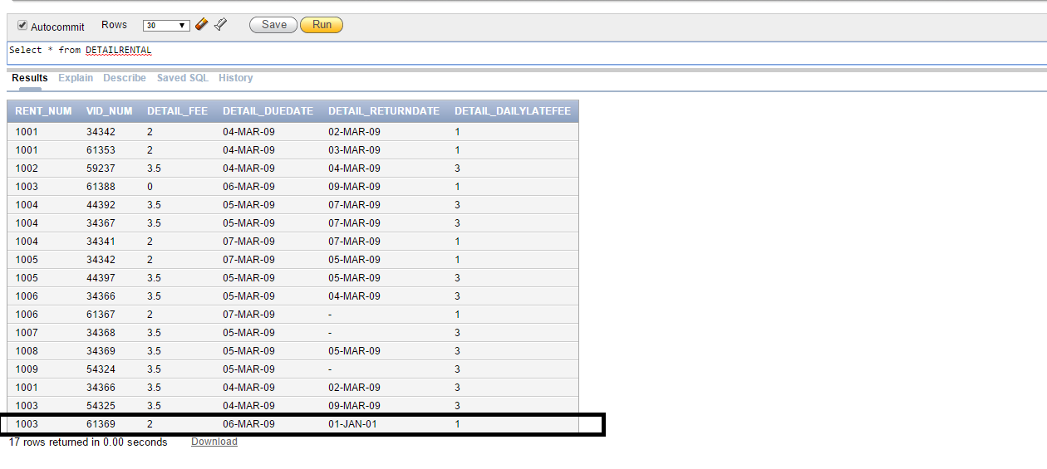

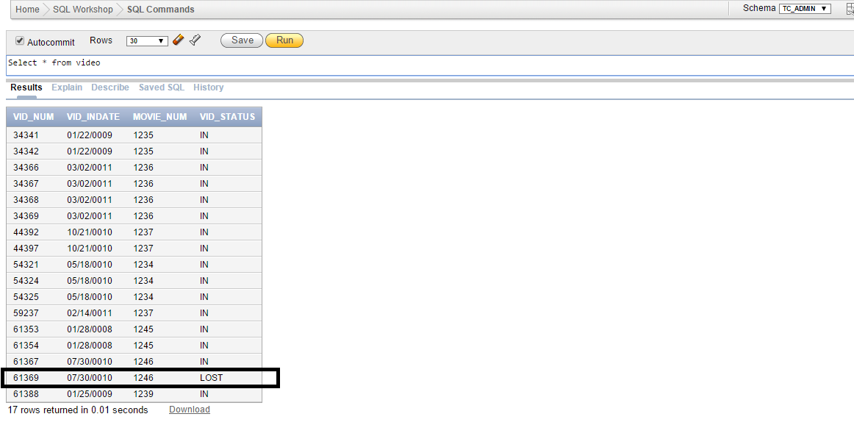

- UPDATE DETAILRENTAL SET DETAIL_DUEDATE = '09-MAR-09' where VID_NUM = 61369
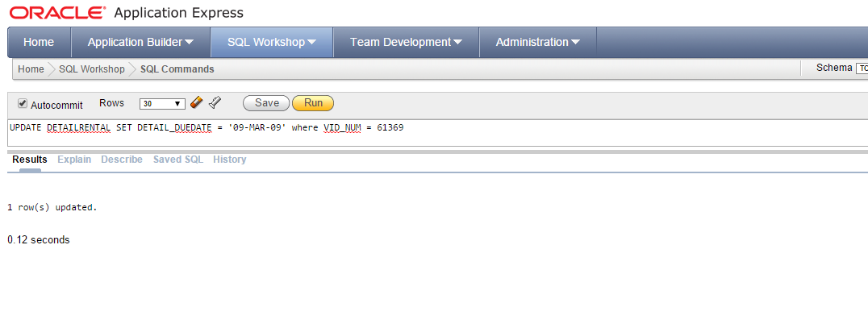

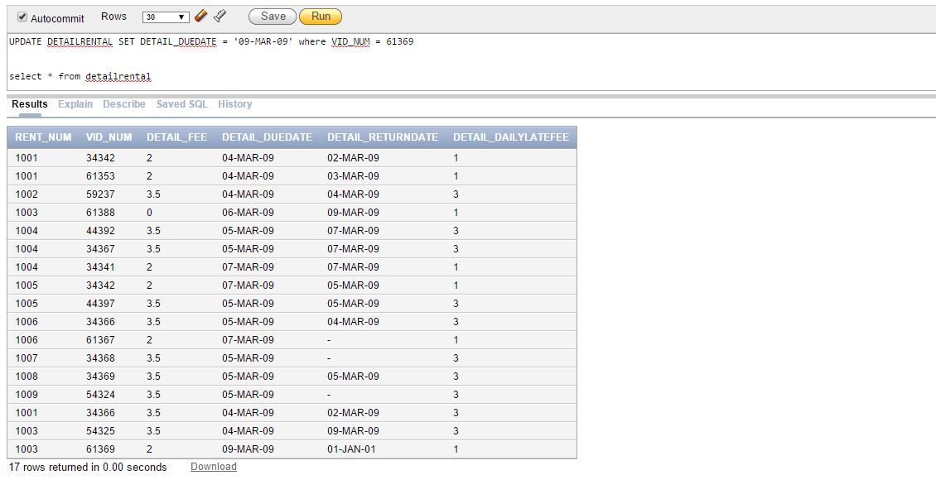

select dr.rent_num, dr.vid_num, v.movie_num, m.movie_title, v.vid_status, dr.detail_duedate, dr.detail_returndate
from detailrental dr, video v, movie m
where dr.vid_num = v.vid_num and m.movie_num = v.movie_num

Solution:
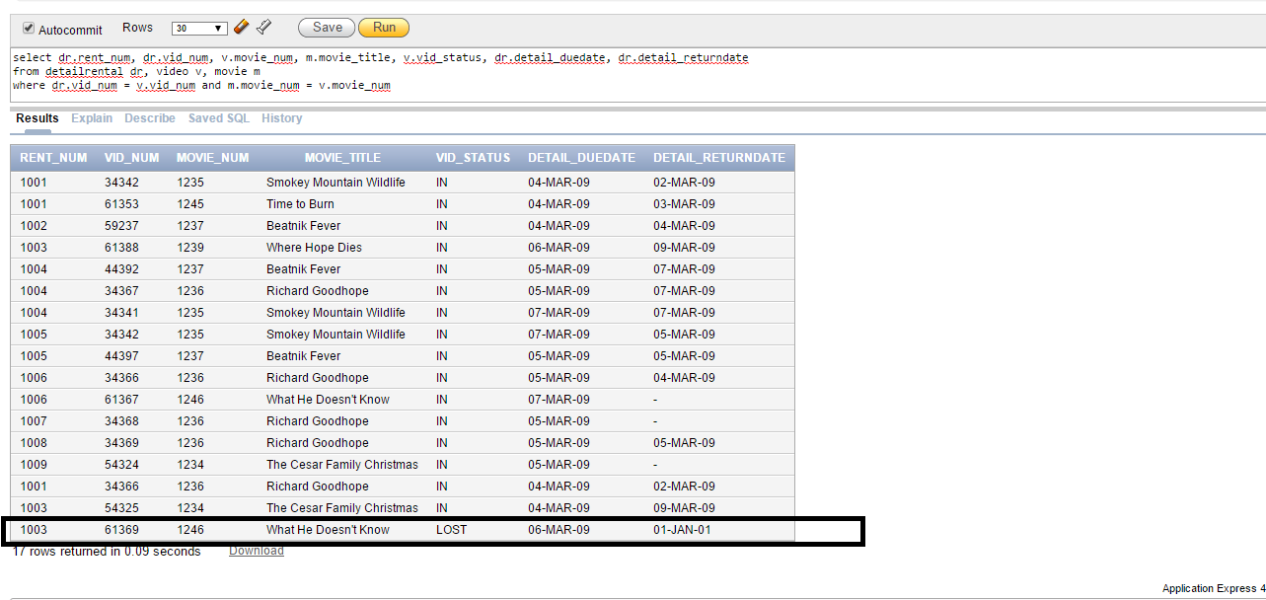

(9 pts for Trigger, 4 points for update statements, 5 points for output)

Problems 3-7 are based on the following query:

SELECT v.movie_num, movie_title, count(v.movie_num) as "Number of Videos"
FROM video v, movie
WHERE v.movie_num = movie.movie_num
GROUP BY v.movie_num, movie_title
ORDER BY "Number of Videos" DESC

- Write the SQL command(s) to create statistics for these tables. (2 pts)

Solution:
ANALYZE TABLE VIDEO COMPUTE STATISTICS;
ANALYZE TABLE MOVIE COMPUTE STATISTICS;

- Write the command to create an explain plan for this query. (2 pts)

Solution:
ANALYZE TABLE VIDEO COMPUTE STATISTICS;
ANALYZE TABLE MOVIE COMPUTE STATISTICS;

EXPLAIN PLAN FOR SELECT v.movie_num, movie_title, count(v.movie_num) as "Number of Videos"
FROM video v, movie
WHERE v.movie_num = movie.movie_num
GROUP BY v.movie_num, movie_title
ORDER BY "Number of Videos" DESC;

- Display the access plan given for this query. (3 pts) (Attach a screen shot of the results)

Solution:
SELECT * FROM TABLE(DBMS_XPLAN.DISPLAY);

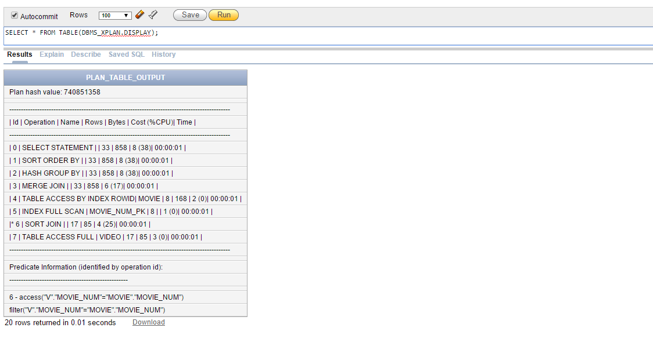

- Should you create an index? If so, what would the index column(s) be and why would you create that index? If not, explain your reasoning. (3 pts)

Solution:
- Yes, Index should be created.
- Index can be created on Movie_Num on Video table since it is part of group by and order by clause.
- Creating an index speeds up performance.

- Create an index on MOVIE_NUM in the Video table. Show the SQL command to create the index. Update your statistics and rerun your explain plan. Create an updated explain plan for this query. Display the access plan given for this query. What difference did this change make? (3 pts)

Solution:
CREATE INDEX VIDEO_INDEX ON VIDEO(MOVIE_NUM);

ANALYZE TABLE MOVIE COMPUTE STATISTICS;
ANALYZE TABLE VIDEO COMPUTE STATISTICS;

EXPLAIN PLAN FOR SELECT v.movie_num, movie_title, count(v.movie_num) as "Number of Videos"
FROM video v, movie
WHERE v.movie_num = movie.movie_num
GROUP BY v.movie_num, movie_title
ORDER BY "Number of Videos" DESC;

SELECT * FROM TABLE(DBMS_XPLAN.DISPLAY);

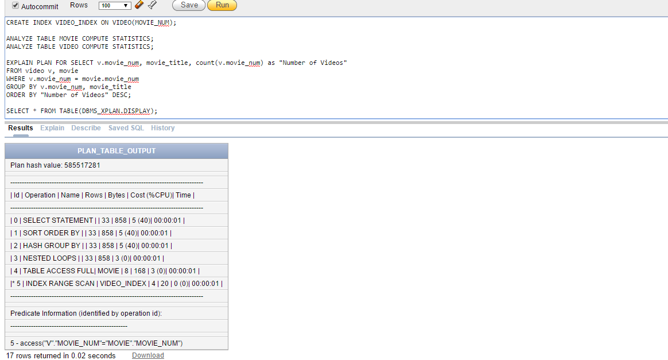

After creating index on Movie_Num, CPU processing cost has been reduced.

